Bridging Lab Dreams to Market Realities: Why Science Needs Management Now?

Abstract
Brilliant scientific discoveries often fail to reach society—not due to lack of innovation, but due to lack of management insight. This article examines the widening gap between laboratory breakthroughs and market implementation, particularly in the Indian research ecosystem, where commercialization bottlenecks limit societal impact. It argues that compulsory management education for science students—covering innovation management, intellectual property, entrepreneurship, and scaling—can transform researchers into innovation leaders.



Author: SARVAGGYA GOEL
Email ID: Goelsarvaggya@gmail.com

Sarvaggya Goel is the 2018-2023 BS-MS Gold Medalist in Chemical Sciences from IISER Kolkata. She blends strong scientific foundations with management expertise through her PGDM in Operations Management. Recognized with the IFERD Excellence Award, she consistently demonstrates academic and professional excellence. With growing leadership exposure in corporate governance and operations, she is driven to bridge science, strategy, and real-world impact.

Bridging Lab Dreams to Market Realities: Why Science Needs Management Now?

Imagine a ground-breaking scientific discovery locked away in a lab, gathering dust while the world desperately needs it—like a life-saving drug that never reaches patients because no one knew how to scale production or navigate markets. This "valley of death" between lab benches and store shelves drains billions in research funding, especially in India, where pure science brilliance often fizzles without business savvy. Bridging science and management isn't just smart—it's essential for turning ideas into sustainable impact.¹

Fig. 1: Where Innovation Meets Execution - Turning Scientific Discovery into Scalable Impact
The Hidden Crisis
Labs worldwide churn out innovations, but most fail to scale due to overlooked commercial realities like cost, manufacturing hurdles, and market fit. In biotech and materials science, for instance, the shift from prototype to mass production hits a "scalability bottleneck," wasting public money on unviable projects. India's research ecosystem mirrors this: despite heavy investments, weak spin-off cultures and policy gaps mean breakthroughs rarely boost societal good, turning potential into "lost opportunities."²
Science-Management Divide
Researchers excel at theory but often ignore practice, creating a persistent "science-practice gap" that's a grand challenge in fields like management and beyond. Surveys of academics and executives reveal shared frustrations—scientists prioritize publications over applicability, while managers crave actionable insights. This chasm widens in closed-door labs, where horizons shrink to equations, blind to the vast business ocean.³
Compulsory Management for Scientists
Exposing science students to management courses—on scaling, IP, entrepreneurship—broadens their worldview and equips them to commercialize work. Benefits include entrepreneurial mind-sets, patent savvy for funding attraction, and skills like decision-making that open doors to start-ups or industry R&D. Science grads with management training grasp organizational behaviour, boosting efficiency in real-world applications like healthcare process improvements.⁴
Compulsory management education for scientists addresses a critical blind spot, transforming lab geniuses into innovation leaders who can scale discoveries for real-world impact.
Core Curriculum Essentials
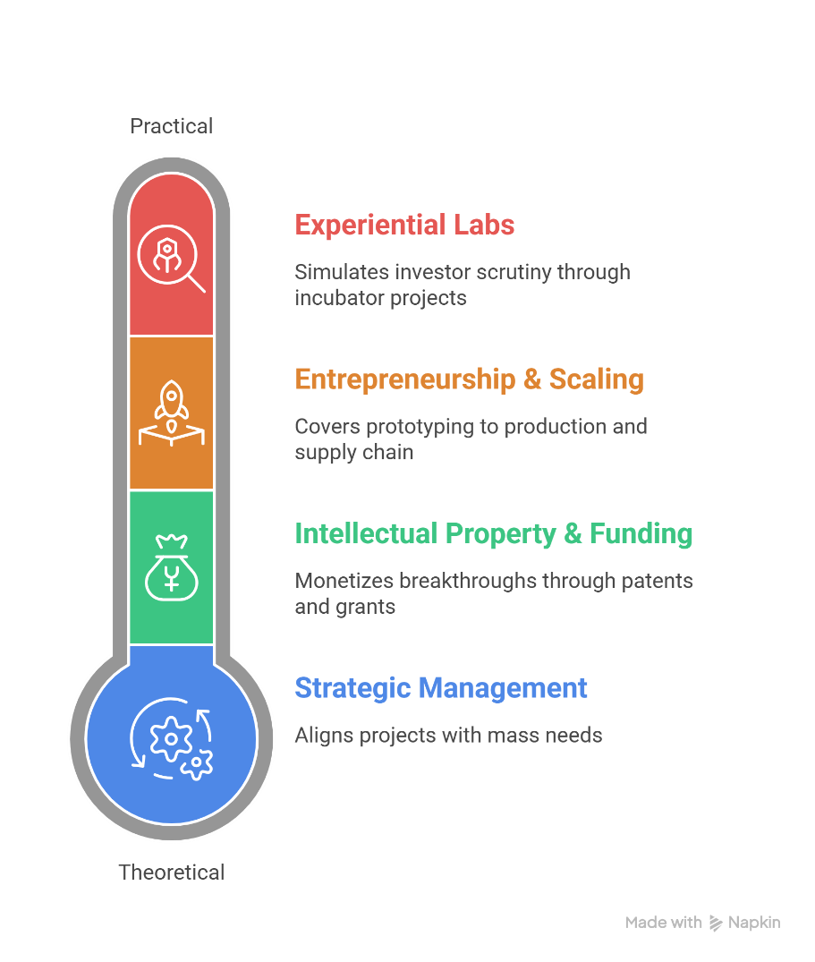
Fig. 2: Core curriculum essentials range from theoretical to practical applications
Institutions like IITs and IISERs, hubs of pure science with integrated research-education models, are ideal for mandatory modules in business strategy and innovation management. Introduce 12-18 credits across undergrad and grad programs, blending theory with hands-on projects:
- Entrepreneurship & Scaling: Modules on prototyping to production, covering cost modelling, supply chain pitfalls, and lean start-up methods—directly tackling "desk-to-shelf" viability gaps.⁵
- Intellectual Property & Funding: Patent filing, licensing strategies, and pitching to VCs; scientists learn to monetize breakthroughs, raising millions via grants like India's BIRAC BIG.⁶
- Strategic Management: Organizational behaviour, market analysis, and sustainability metrics, empowering researchers to align projects with mass needs, like affordable biotech for rural health.
- Experiential Labs: Mandatory incubators with mentorship—prototype a lab idea into a business plan within a semester, simulating real investor scrutiny.
Proven Benefits
Graduates gain "T-shaped" skills: deep science expertise with broad business acumen. Studies show such training boosts start up success by 3x, as scientists overcome fear of failure, file 40% more patents, and launch ventures confidently. In healthcare, management-savvy PhDs optimize clinical trials for scalability, slashing costs by 25% while ensuring ethical mass rollout. Broader horizons mean less tunnel vision—scientists see the "vast sea" of opportunities, from green tech spin-offs to AI-driven diagnostics.⁷
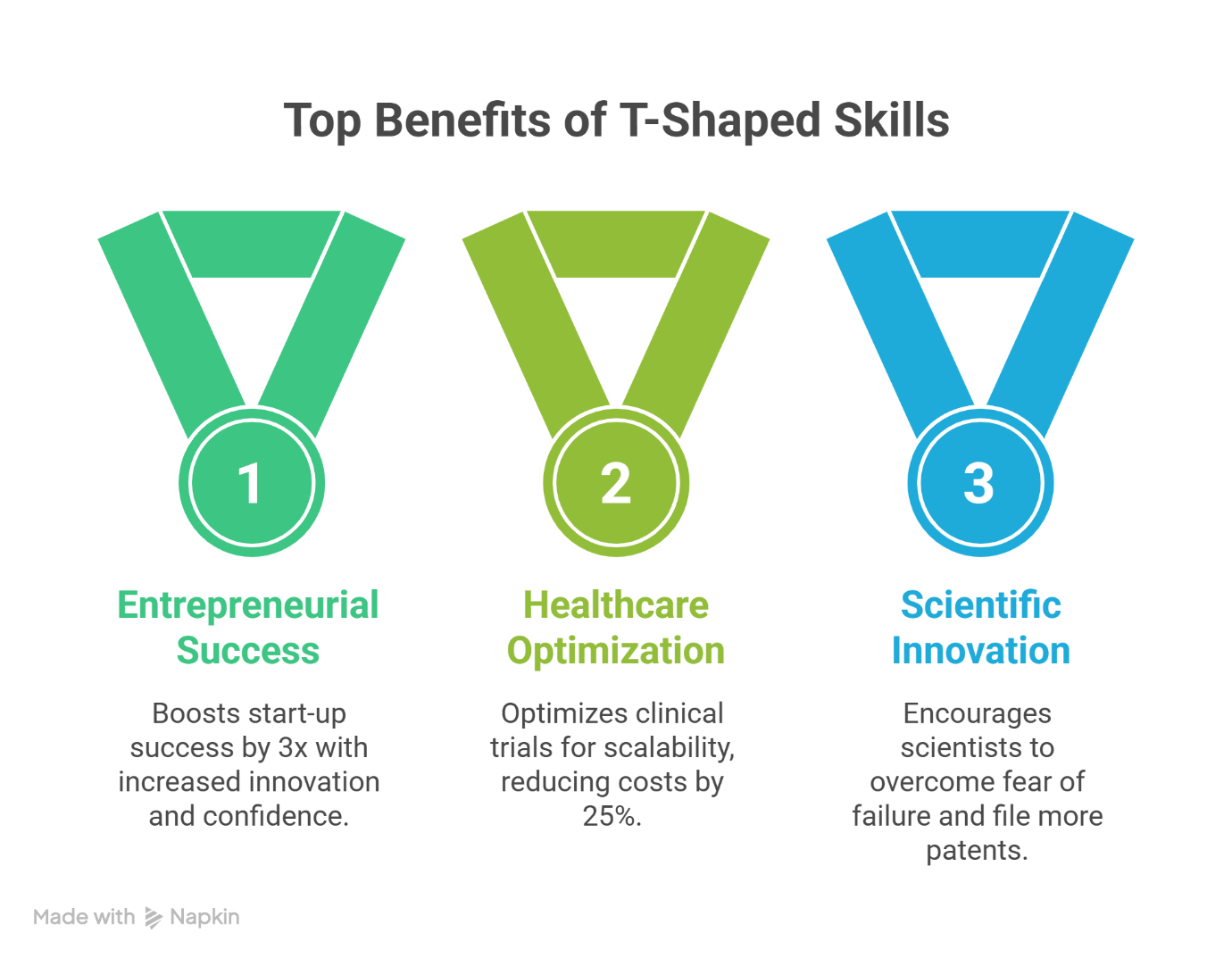Fig. 3: Top benefits of “T-shaped” skills
India-Specific Rollout
Target IITs and IISERs first: IIT Bombay's SINE (Society for Innovation and Entrepreneurship) incubator proves the model, with alumni start-ups valued at billions.⁸ Mandate via UGC guidelines—2nd-year BS-MS students take "Innovation Management" as core, integrated with labs. Government ties it to Start-up India incentives: course completers get priority SISFS (Start-up India Seed Fund Scheme) funding (₹20-50 lakhs).⁹
The Path Forward: Overcoming Resistance
Roll out pilot programs at IITs/IISERs: core credits in entrepreneurship, scaling, and IP, partnered with incubators. Track success via start-up launches and funding raised—transforming "desk-to-shelf" failures into organizational gold. India's science talent, unleashed with management lenses, could lead global innovation, proving that broadened horizons end the funding drain forever.
Scientists fear "diluting" focus, but data counters this: management boosts research output via better funding. Frame it as empowerment—demystify business to unleash potential. Institutions gain prestige as "science-business hubs," attracting global talent.
This bridge doesn't constrain horizons; it expands them infinitely, turning isolated eureka moments into sustainable empires.

References:
- MRL Consulting Group. (2025). From lab to market: Challenges in scaling biotech innovations. https://www.mrlcg.com/resources/blog/from-lab-to-market-challenges-in-scaling-biotech-innovations/
- Nature. (2023). India struggles to turn science into societal benefits. https://www.nature.com/articles/d41586-023-03914-6
- Banks, G. C., et al. (2016). Management’s science–practice gap: A grand challenge for all stakeholders. Academy of Management Journal, 59(6). https://journals.aom.org/doi/10.5465/amj.2015.0728
- Blankesteijn, M., Bossink, B. & van der Sijde, P. Science-based entrepreneurship education as a means for university-industry technology transfer. Int Entrep Manag J 17, 779–808 (2021). https://doi.org/10.1007/s11365-019-00623-3
- MRL Consulting Group. (2025). From lab to market challenges. https://www.mrlcg.com/resources/blog/from-lab-to-market-challenges-in-scaling-biotech-innovations/
- BIRAC. (2026). Biotechnology Ignition Grant Scheme (BIG). https://birac.nic.in/big.php
- Nature. (2023). India science commercialization. https://www.nature.com/articles/d41586-023-03914-6
- SINE Startups’ Valuations and Successes APN News. (2025). Society for Innovation and Entrepreneurship (SINE) at IIT Bombay — SINE’s portfolio includes unicorn and industry-leading companies supported through incubation. Retrieved from https://www.apnnews.com/society-for-innovation-entrepreneurship-sine-at-iit-bombay/
- Department for Promotion of Industry and Internal Trade. Start-up India Seed Fund Scheme (SISFS) eligibility & benefits. India Science & Technology Portal. Retrieved February 21, 2026, from https://www.indiascienceandtechnology.gov.in/funding-opportunities/startups/startup-india-seed-fund-scheme-sisfs

